Auxiliary materials to the Manual of the LOTOS code with
the description of several testing examples
created using LOTOS-09 version
www.ivan-art.com/science/LOTOS_09

Table of content:

0. Introduction |  | 2
1. DATASET2 (Chile, offshore, synthetic dataset) |  | 2
 | 1.1. DATASET2/model_01 – “real” data inversion, nodes, Vp-Vs scheme | 2
 | 1.2. DATASET2/MOD_BL_1 – “real” data inversion, cells, Vp-Vs scheme | 4
 | 1.3. DATASET2/BRD_30km – synthetic modeling, checkerboard | 5
 | 1.4. DATASET2/VBRDmod2 – synthetic modeling, vertical resolution | 6
 | 1.5. DATASET2/SMILE_01 – synthetic modeling, horizontal anomalies | 7
 | 1.6. DATASET2/VER_free – synthetic modeling, vertical anomalies | 8
2. BOLIVAR_ (Costa-Rica, on- and off- shore, synthetic dataset) |  | 9
 | 2.1. BOLIVAR_/model_01 – “real” data inversion, nodes, Vp-Vs scheme | 10
 | 2.2. BOLIVAR_/BLOCK_01 – “real” data inversion, cells, Vp-Vs scheme | 11
 | 2.3. BOLIVAR_/Ver_BRD1 – synthetic modeling, vertical resolution | 12
3. TOBA_001 (Toba Caldera, N. Sumatra, synthetic dataset) |  | 13
 | 3.1. TOBA_001/model_01 – “real” data inversion, nodes, Vp-Vs scheme | 14
4. TOBA_REA (Toba Caldera, N. Sumatra, real data) |  | 16
 | 4.1. TOBA_REA/real_VPX – real data inversion, Vp-Vp/Vs scheme | 16
5. Tests for the GAP criterion, AREAS: “GAP__180”, “GAP__280”, “GAP__360” |  | 18
 | 5.1. GAP__180/model_01 – Java Area, events with GAP<180˚ | 18
 | 5.2. GAP__280/model_01 – Java Area, events with GAP<280˚ | 20
 | 5.3. GAP__360/model_01 – Java Area, all events within 5˚ distance | 22
6. TURKEY__ (Marmara Sea area, checkerboard) |  | 24
 | 6.1. TURKEY__/model_01 – “real” data inversion, nodes, Vp-Vs scheme | 24
7. EGYPT_02 (Egypt area, checkerboard) |  | 25
 | 7.1. EGYPT_02/BOARD_01 – “real” data inversion, nodes, Vp-Vs scheme | 25

0. Introduction

Here we present several examples of using the LOTOS code for different datasets. In most cases we use configurations of sources and receivers corresponding to real experiments. However, due to property right problems we cannot always present observed travel times. Therefore the datasets which are used as the initial ones are mostly generated artificially by ray tracing through synthetic models. However, after computing the travel times, we “forget” about the model and use the same procedure as for processing real datasets.

All the indicated datasets can be re-run by any person using the presented EXE files for the LOTOS code which can be freely downloaded from the web page “www.ivan-art.com/science/LOTOS_09”. If the parameters are not changed, the results will be the same as shown in this overview. It would be a good teaching lesson to perform the inversion for the presented examples with different free parameters (grid spacing, inversion parameters, different starting models etc) to see the influence of each of them to the result.

When starting processing real datasets, a user can take one of the presented examples as a template. In this case, one should select a dataset which is the most similar to his/her one. Then one should change the geographical coordinates of the central point of the study area and prepare two files with stations and travel times in the “inidata” folder. Then the inversion can start.

The previews of the obtained results can be seen in folder “PICS” in the corresponding subfolders. All the pictures presented here are obtained in this way. At the same time, to produce high-quality pictures suitable for publication, it is recommended using more sophisticated visualization tools (such as Surfer).

In case of problems, errors and inconsistencies, please address to the author of the LOTOS code, Ivan Koulakov (KoulakovIY@ipgg.nsc.ru).

1. AREA: “DATASET2”

This dataset is fully artificial. It was designed specially for planning a network in an off-shore experiment in Central Chile.

Number of stations | 12
Number of events | 202
Number of P rays: | 1952
Number of S rays: | 1237

1.1. MODEL: “DATASET2/MODEL_01”

The processing of this model corresponds to inversion of real data. However, the model has been created artificially using synthetic model shown in Figure 1 (the model parameters can be seen in “DATASET2/MOD_INI_”).

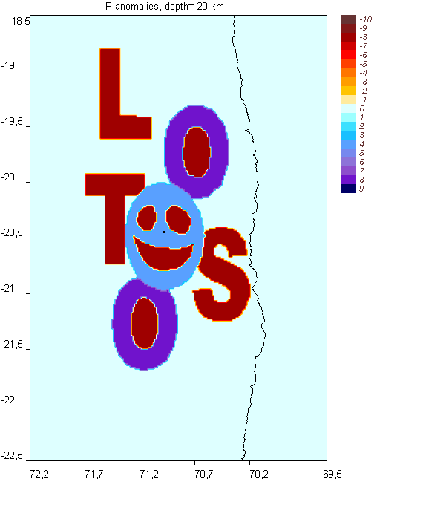
Figure 1. Initial model which was used to create the “real” dataset in “DATASET2/inidata/rays.dat”. Picture is from “/PICS/DATASET2/MOD_INI_/hor/syn1_ 2.png”

Table 1.1. Parameters of inversion for model “DATASET2/model_01”
Data processing | “real”
Inversion scheme | Vp-Vs
Number of iterations | 5
1D optimization | YES
Parameterization | nodes
Figure with results | 2
Approximate calculation time: | 35-40 min
Size of the model folder after calculations : | 27 Mb

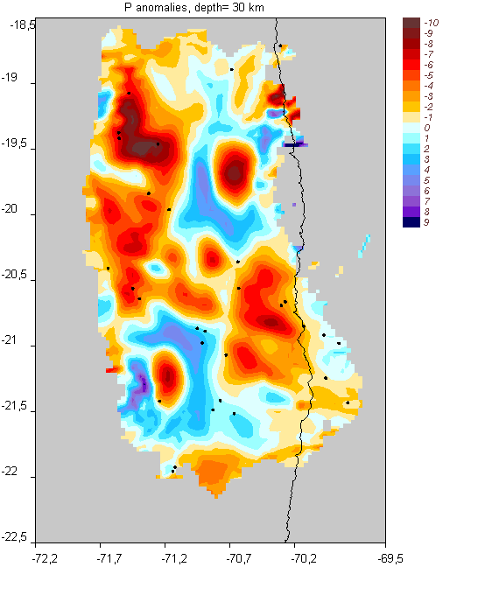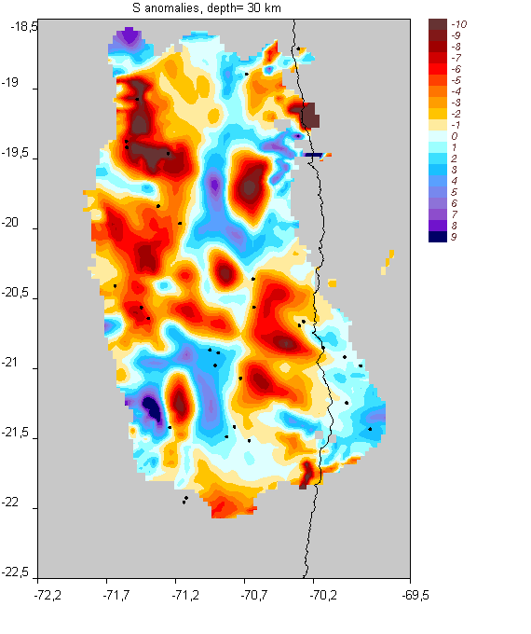
Figure 2. Inversion results for P and S velocity anomalies at 30 km depth based on model “DATASET2/model_01”. Pictures are from:
“/PICS/DATASET2/model_01/hor/dv15_ 3.png”
“/PICS/DATASET2/model_01/hor/dv25_ 3.png”
1.2. MODEL: “DATASET2/MOD_BL_1”

Same as “DATASET2/model_01”, but with the use of CELL parameterization. .

Table 1.2. Parameters of inversion for model “DATASET2/MOD_BL_1”
Data processing | “real”
Inversion scheme | Vp-Vs
Number of iterations | 5
1D optimization | YES
Parameterization | CELLS
Figure with results | 3
Approximate calculation time: | 45-50 min
Size of the model folder after calculations : | 37 Mb

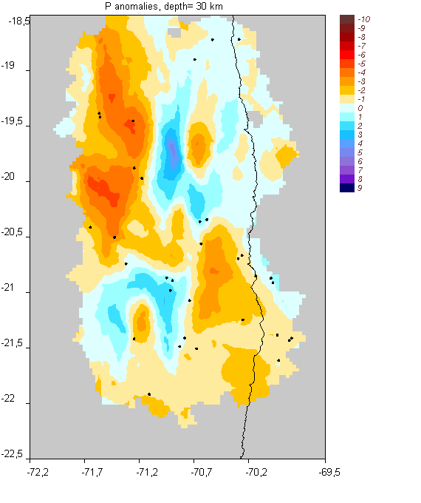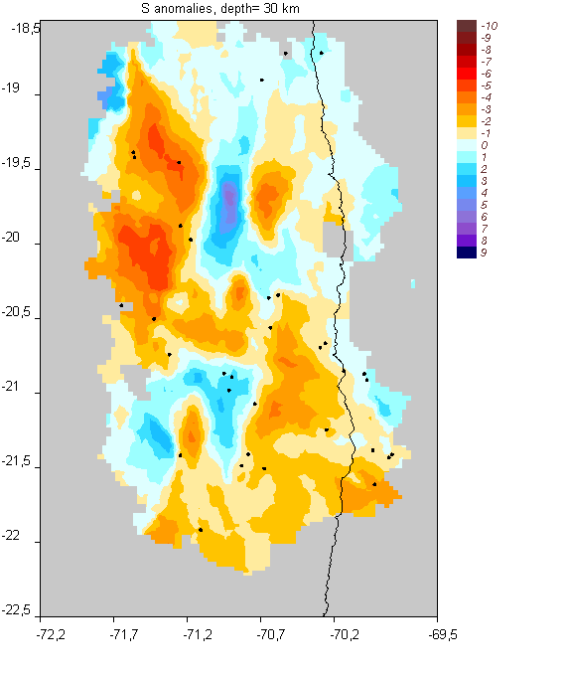
Figure 3. Inversion results for P and S velocity anomalies at 30 km depth based on model “DATASET2/MOD_BL_1”. Pictures are from:
“/PICS/DATASET2/MOD_BL_1/hor/dv15_ 3.png”
“/PICS/DATASET2/MOD_BL_1/hor/dv25_ 3.png”
1.3. MODEL: “DATASET2/BRD_30km”

Checkerboard is represented by alternated cells with horizontal spacing of 30 km and unlimited in the vertical direction.

Table 1.3. Parameters of inversion for model “DATASET2/BRD_30km”
Data processing | “synthetic”
Noise: | 0.8 of real remnant residuals
Inversion scheme | Vp-Vs
Number of iterations | 3
1D optimization | YES
Parameterization | NODES
Figure with results | 4
Approximate calculation time: | 30 min
Size of the model folder after calculations : | 14 Mb

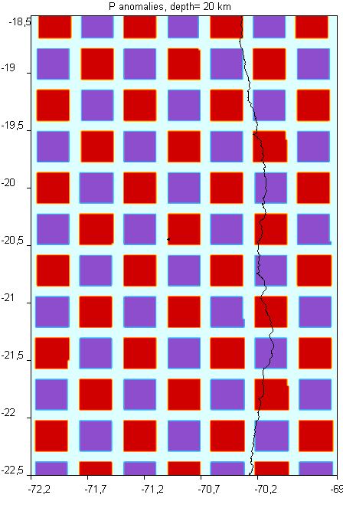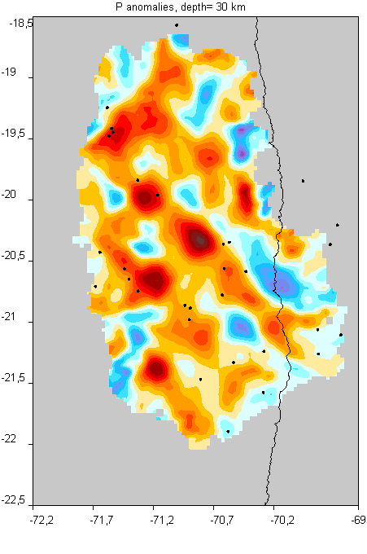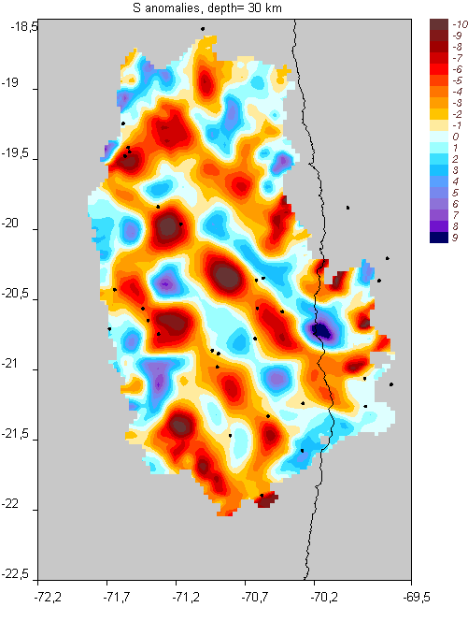
Figure 4. Synthetic model and inversion results for P and S velocity anomalies at 30 km depth based on model “DATASET2/BRD_30km”. Pictures are from:
“/PICS/DATASET2/BRD_30km/hor/syn1_ 2.png”
“/PICS/DATASET2/BRD_30km/hor/dv13_ 3.png”
“/PICS/DATASET2/BRD_30km/hor/dv23_ 3.png”

1.4. MODEL: “DATASET2/VBRDmod2”

Checkerboard is represented by alternated cells along the vertical section.

Table 1.4. Parameters of inversion for model “DATASET2/VBRDmod2”
Data processing | “synthetic”
Noise: | 0
Inversion scheme | Vp-Vs
Number of iterations | 5
1D optimization | YES
Parameterization | NODES
Figure with model and results | 5
Approximate calculation time: | 35 min
Size of the model folder after calculations : | 16 Mb

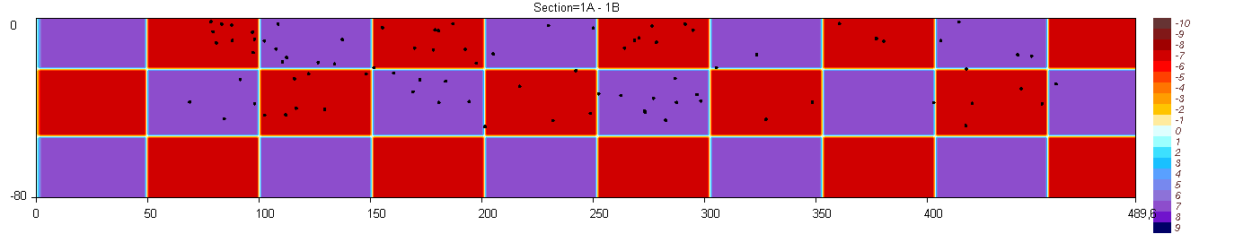
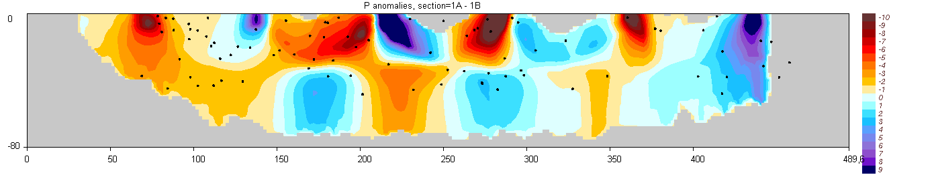
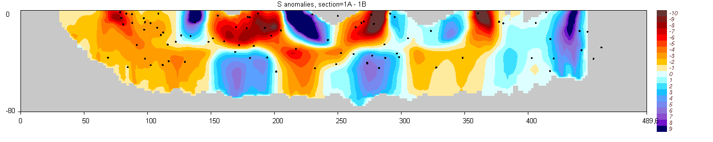
Figure 5. Synthetic model and inversion results for P and S velocity anomalies at 30 km depth based on model “DATASET2/VBRDmod2”. Pictures are from:
“/PICS/DATASET2/VBRDmod2/ver/syn_dv 1.png”
“/PICS/DATASET2/VBRDmod2/ver/dv15_ 1.png”
“/PICS/DATASET2/VBRDmod2/ver/dv25_ 1.png”

1.5. MODEL: “DATASET2/SMILE_01”

Synthetic test with free anomalies defined in map projection.

Table 1.5. Parameters of inversion for model “DATASET2/SMILE_01”
Data processing | “synthetic”
Noise: | Random: 0.15 s (P), 0.3 s (S)
Inversion scheme | Vp-Vs
Number of iterations | 5
1D optimization | YES
Parameterization | NODES
Figure with results | 6
Approximate calculation time: | 35 min
Size of the model folder after calculations : | 15 Mb

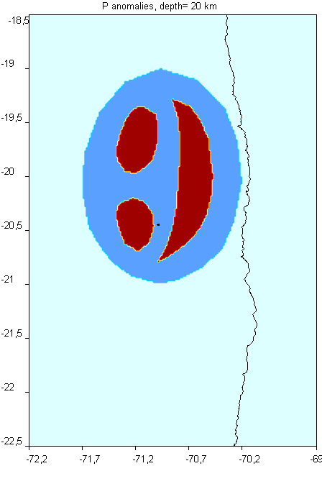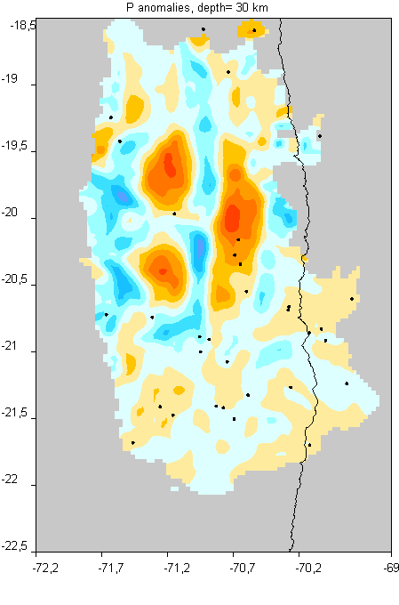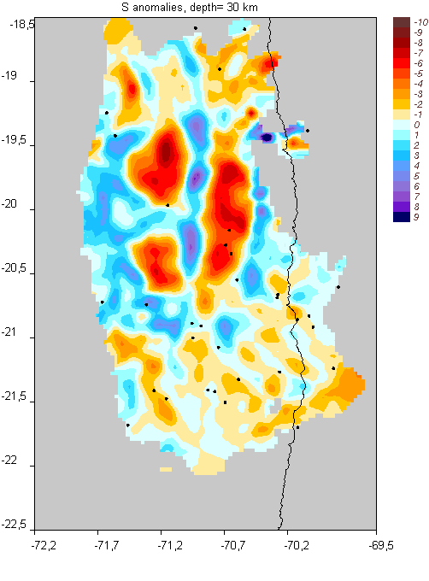
Figure 6. Synthetic model and inversion results for P and S velocity anomalies at 30 km depth based on model “DATASET2/SMILE_01”. Pictures are from:
“/PICS/DATASET2/SMILE_01/hor/syn1_ 2.png”
“/PICS/DATASET2/SMILE_01/hor/dv13_ 3.png”
“/PICS/DATASET2/SMILE_01/hor/dv23_ 3.png”

1.6. MODEL: “DATASET2/VER_free”

Checkerboard is represented free anomalies defined along the vertical section.

Table 1.6. Parameters of inversion for model “DATASET2/VER_free”
Data processing | “synthetic”
Noise: | 0
Inversion scheme | Vp-Vs
Number of iterations | 5
1D optimization | YES
Parameterization | NODES
Figure with model and results | 7
Approximate calculation time: | 30 min
Size of the model folder after calculations : | 15 Mb

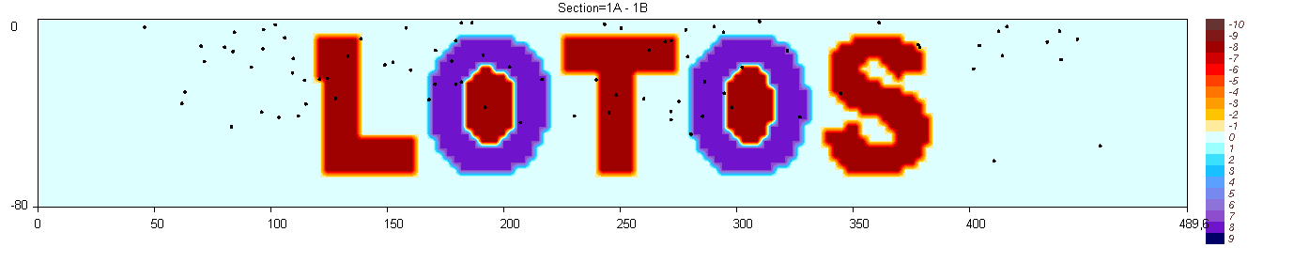
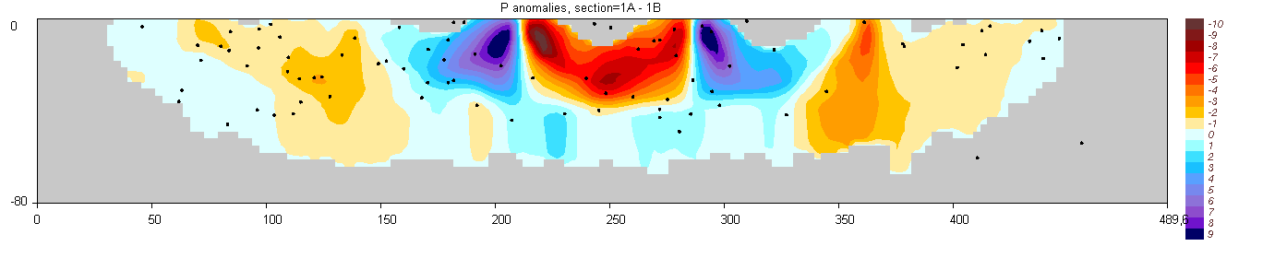
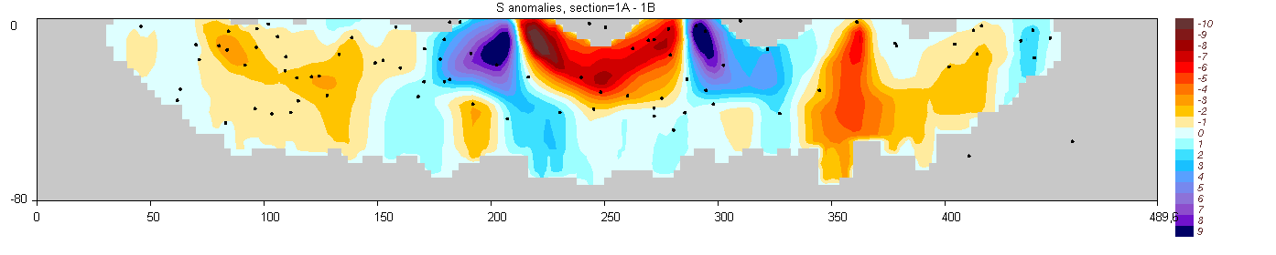
Figure 7. Synthetic model and inversion results for P and S velocity anomalies at 30 km depth based on model “DATASET2/VBRDmod2”. Pictures are from:
“/PICS/DATASET2/VBRDmod2/ver/syn_dv 1.png”
“/PICS/DATASET2/VBRDmod2/ver/dv15_ 1.png”
“/PICS/DATASET2/VBRDmod2/ver/dv25_ 1.png”

2. AREA: “BOLIVAR_”

This dataset uses the data configuration from a real LET experiment in Costa-Rica. The data in the “inidata” folder are computed using the synthetic model which composes the face of Simon Bolivar (Figure 8). This model remains unchanged with depth. The same model was published in Koulakov, (2009, BSSA) in the paper which presents the LOTOS code.

Initial dataset:
Number of stations | 129
Number of events | 1079
Number of P rays: | 24285
Number of S rays: | 6794
Dataset used for inversion:
Number of stations | 108
Number of events | 1074
Number of P rays: | 24197
Number of S rays: | 6744

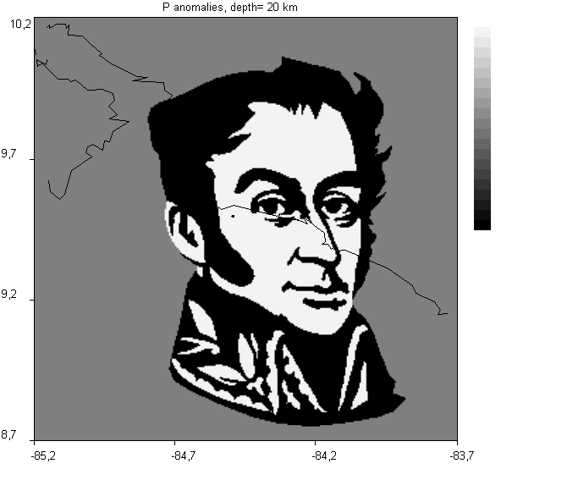
Figure 8. Initial model which was used to create the “real” dataset in “BOLIVAR_/inidata/rays.dat”. Picture is from “/PICS/BOLIVAR_/TRUE_MOD/hor/syn1_ 1.png”
2.1. MODEL: “BOLIVAR_/MODEL_01”

The processing of this model corresponds to inversion of real data. However, the model has been created artificially using synthetic model shown in Figure 8 (the model parameters can be seen in “BOLIVAR_/MOD_INI_”).

Table 2.1. Parameters of inversion for model “BOLIVAR_/MODEL_01”
Data processing | “real”
Inversion scheme | Vp-Vs
Number of iterations | 5
1D optimization | YES
Parameterization | nodes
Figure with results | 9
Approximate calculation time: | 2 hours 40 min
Size of the model folder after calculations : | 68 Mb

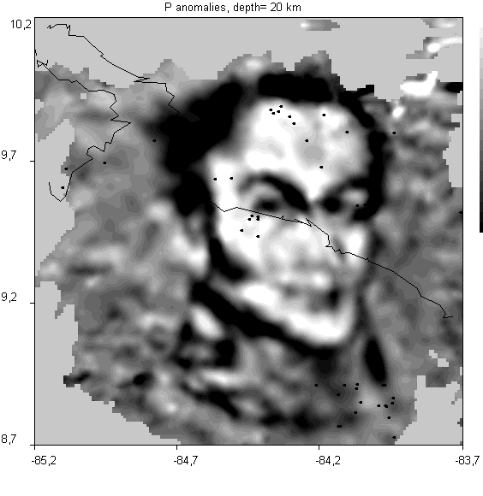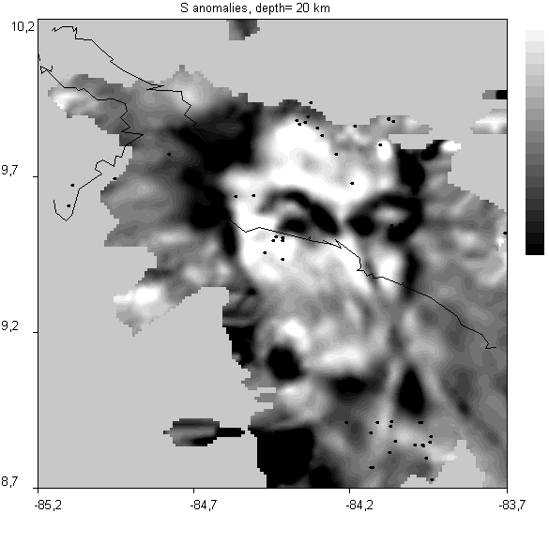
Figure 9. Inversion results for P and S velocity anomalies at 20 km depth based on model “BOLIVAR_/MODEL_01”. Pictures are from:
“/PICS/BOLIVAR_/MODEL_01/hor/dv15_ 1.png”
“/PICS/BOLIVAR_/MODEL_01/hor/dv25_ 1.png”

2.2. MODEL: “BOLIVAR_/BLOCK_01”

Same as “BOLIVAR_/MODEL_01”, but with the use of CELL parameterization. .
.

Table 2.2. Parameters of inversion for model “BOLIVAR_/BLOCK_01”
Data processing | “real”
Inversion scheme | Vp-Vs
Number of iterations | 5
1D optimization | YES
Parameterization | CELLS
Figure with results | 10
Approximate calculation time: | 6 hours 30 min
Size of the model folder after calculations : | 68 Mb

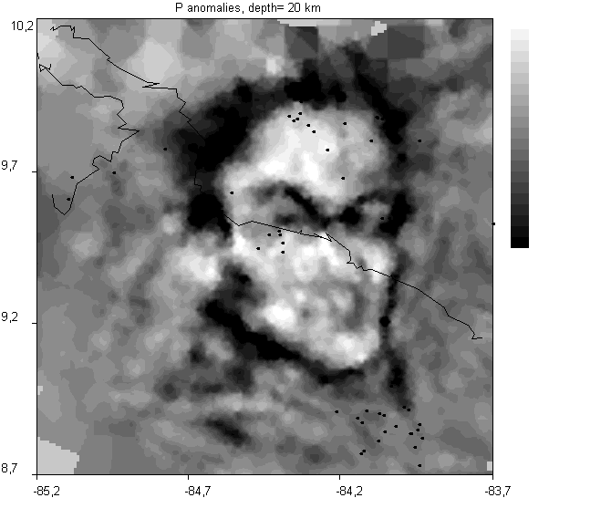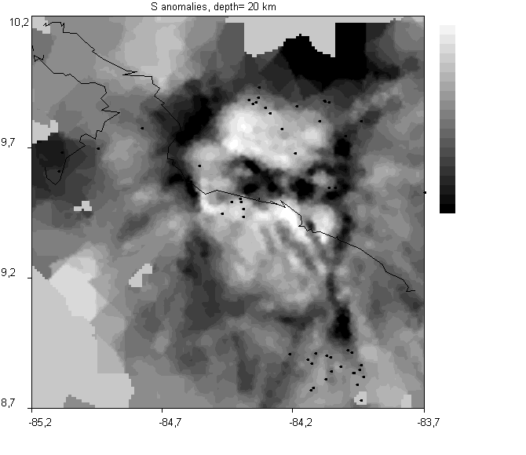
Figure 10. Inversion results for P and S velocity anomalies at 20 km depth based on model “BOLIVAR_/BLOCK_01”. Pictures are from:
“/PICS/BOLIVAR_/BLOCK_01/hor/dv15_ 1.png”
“/PICS/BOLIVAR_/BLOCK_01/hor/dv25_ 1.png”

2.4. MODEL: “BOLIVAR_/Ver_BRD1”

Checkerboard is represented by alternated cells along the vertical section.

Table 2.3. Parameters of inversion for model “BOLIVAR_/Ver_BRD1”
Data processing | “synthetic”
Noise: | 0.15 s (P); 0.20 s (S)
Inversion scheme | Vp-Vs
Number of iterations | 5
1D optimization | YES
Parameterization | NODES
Figure with model and results | 11
Approximate calculation time: | 6 hours
Size of the model folder after calculations : | 69 Mb

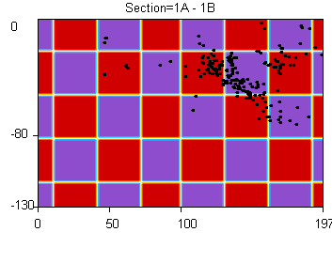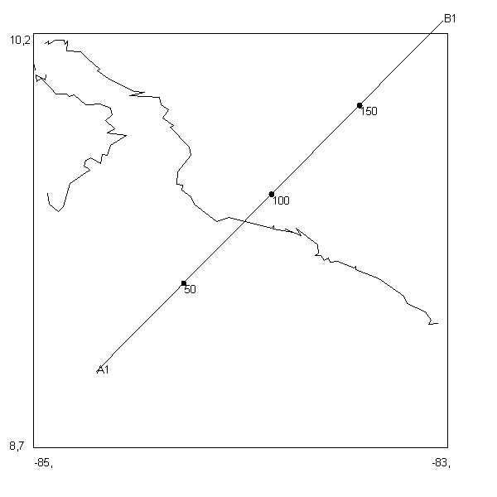
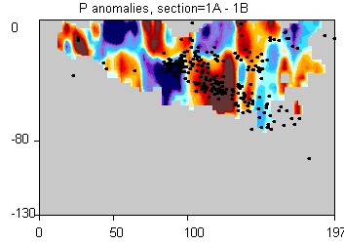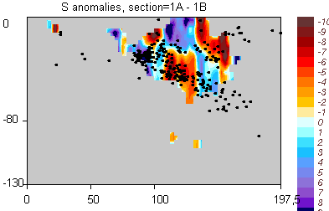

Figure 11. Synthetic model, location of the profile and inversion results for P and S velocity anomalies at 30 km depth based on model “BOLIVAR_/VER_BRD1”. Pictures are from:
“/PICS/BOLIVAR_/VER_BRD1/ver/syn_dv 1.png”
“/PICS/BOLIVAR_/VER_BRD1/ver/dv15_ 1.png”
“/PICS/BOLIVAR_/VER_BRD1/ver/dv25_ 1.png”
“/PICS/BOLIVAR_/VER_BRD1/ver/map.png”

3. AREA: “TOBA_001”

This dataset uses the data configuration from a real LET experiment in the area of Toba Caldera (N.Sumatra). The data in the “inidata” folder are computed using the synthetic model which composes the realistic shapes of anomalies (Figure 12). This model is fully 3D. The same model was published in Koulakov et al., (2009, JGI).

Initial dataset:
Number of stations | 31
Number of events | 390
Number of P rays: | 3377
Number of S rays: | 2462
Dataset used for inversion:
Number of stations | 30
Number of events | 585
Number of P rays: | 3308
Number of S rays: | 2413

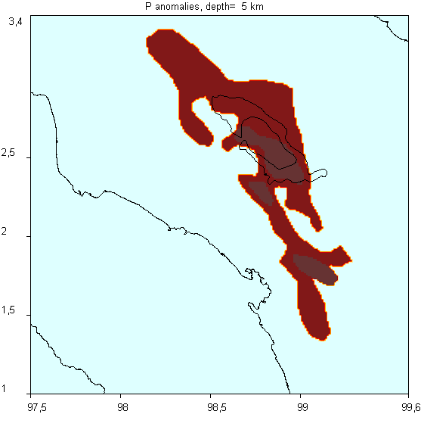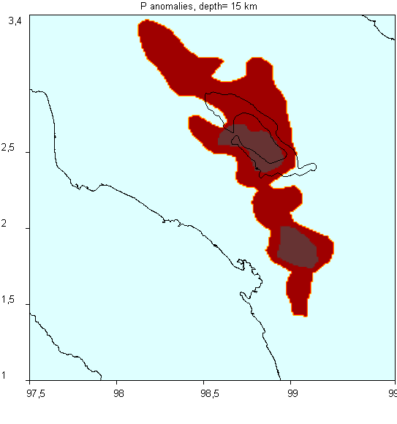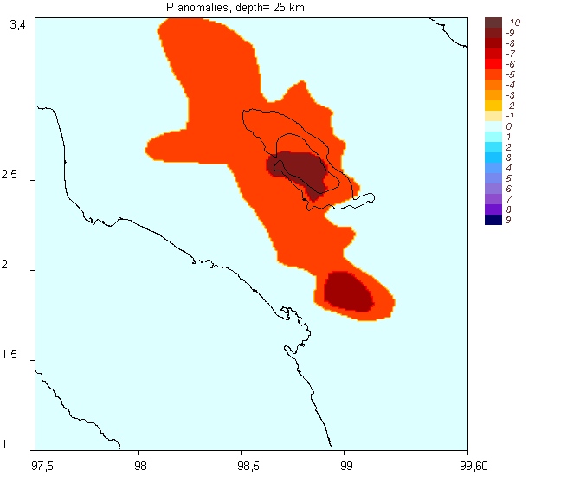

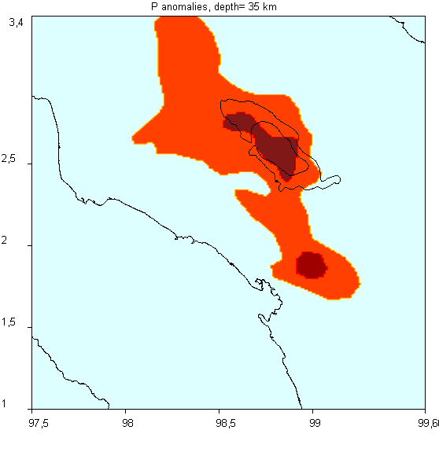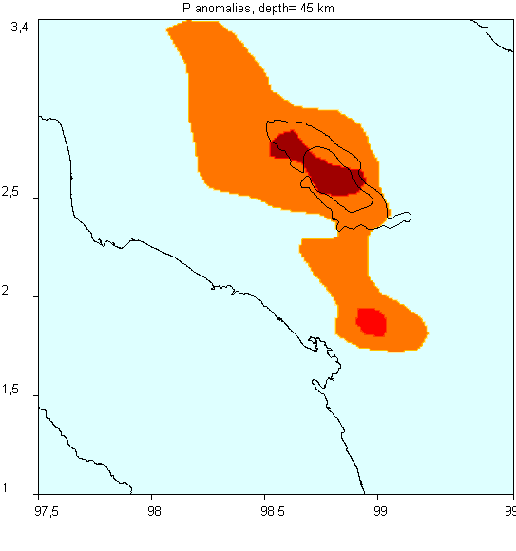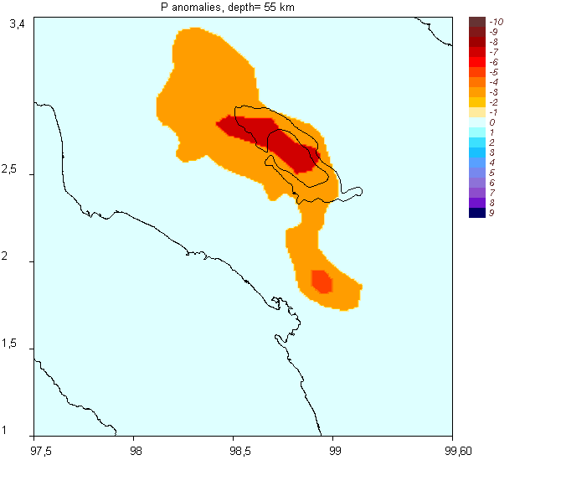

Figure 12. Initial model of P anomalies which was used to create the “real” dataset in “TOBA_001/inidata/rays.dat”. Picture is from “/PICS/TOBA_001/TRUE_MOD/hor/syn1_ M.png” (M=1…6)

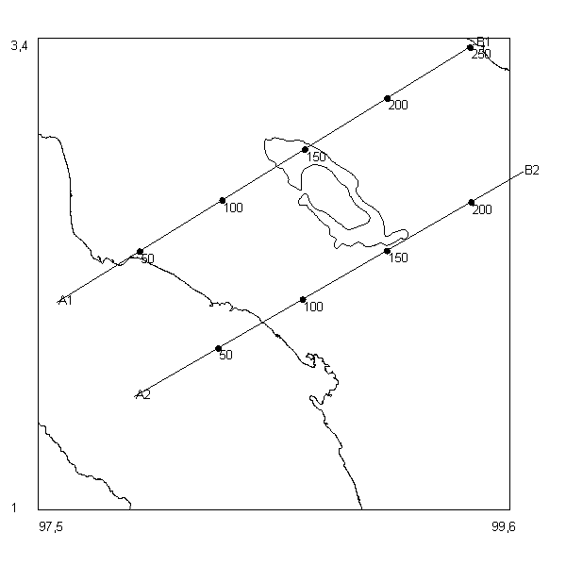  Figure 13. Initial model of P anomalies in two vertical sections which was used to create the “real” dataset in “TOBA_001/inidata/rays.dat”. Picture is from “/PICS/TOBA_001/TRUE_MOD/vert/syn_dv_ M.png” (M=1,2) | 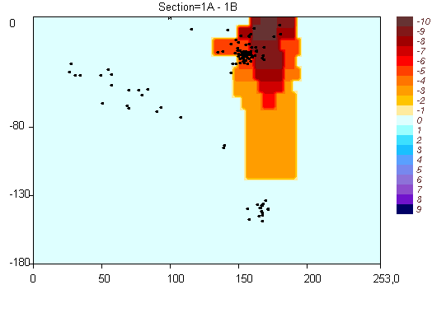
 | 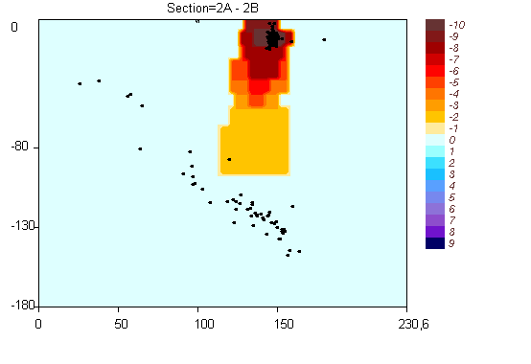

3.1. MODEL: “TOBA_001/model_01”

The processing of this model corresponds to inversion of real data. However, the model has been created artificially using synthetic model shown in Figure 12 (the model parameters can be seen in “TOBA_001/MOD_INI_”).

Table 3.1. Parameters of inversion for model “TOBA_001/model_01”
Data processing | “real”
Inversion scheme | Vp-Vs
Number of iterations | 5
1D optimization | YES
Parameterization | nodes
Figure with results | 14-15
Approximate calculation time: | 1 hour 45 min
Size of the model folder after calculations : | 30 Mb

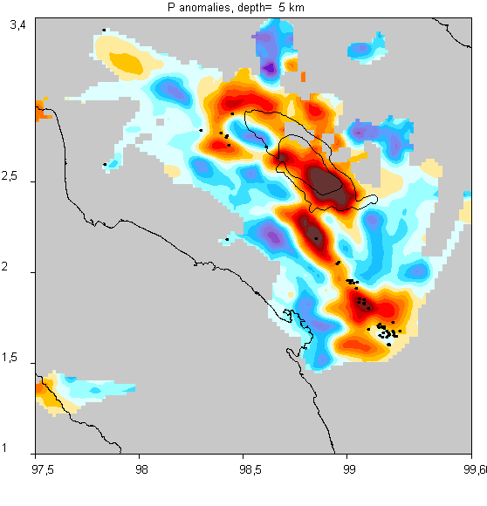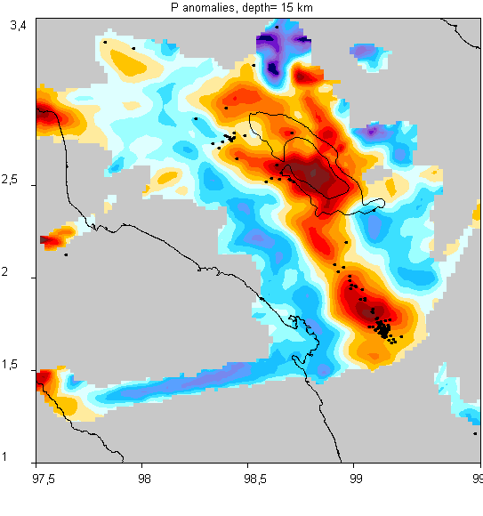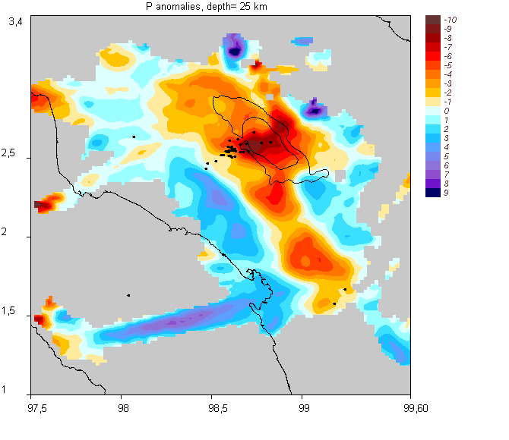
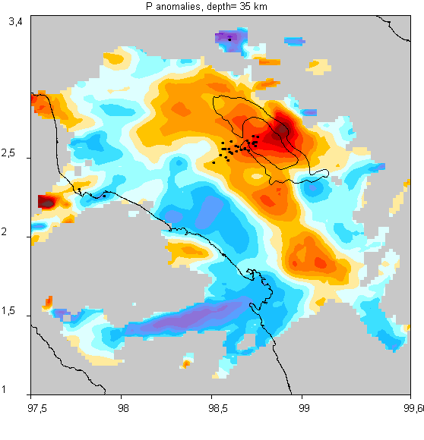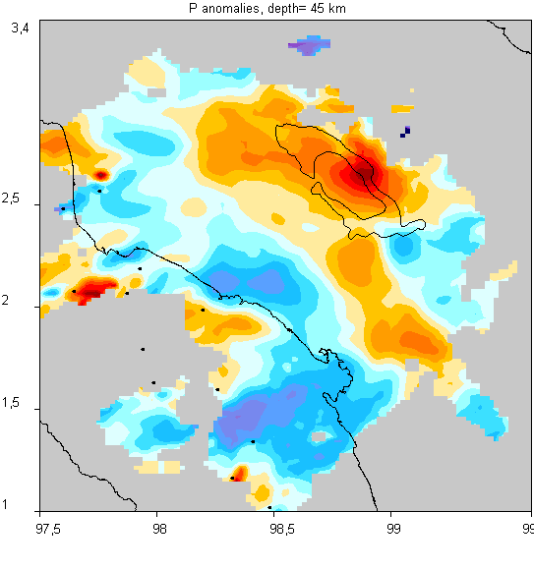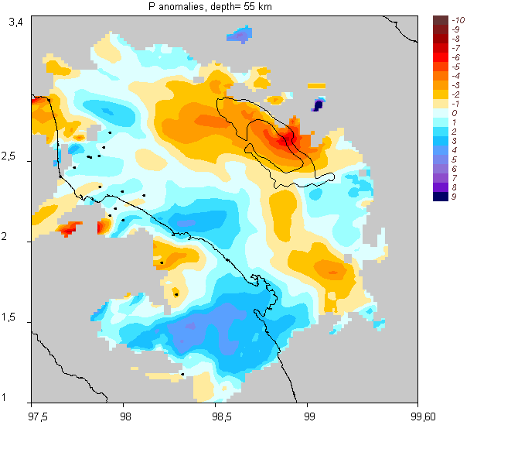
Figure 14. Inversion results for P velocity anomalies in 6 horizontal sections based on model “TOBA_001/model_01”. Pictures are from:
“/PICS/ TOBA_001/model_01/hor/dv15_ M.png”, (M=1…6)

Figure 15. Reconstructed P anomalies in two vertical sections based on model: “TOBA_001/model_01”. Picture is from: “/PICS/TOBA_001/model_01/vert/ver_15 M.png” (M=1,2) | 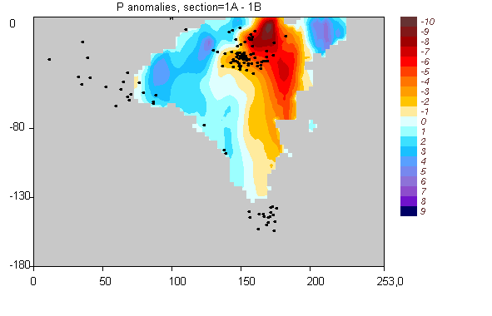
 | 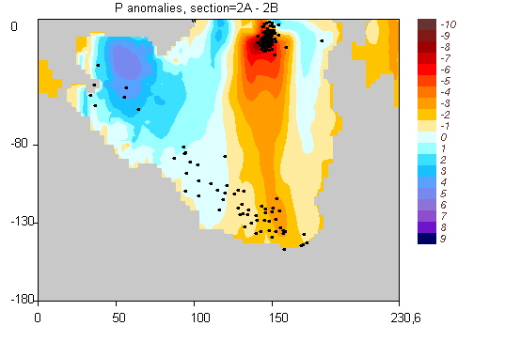

4. AREA: “TOBA_REA”

This is a real dataset uses from LET experiment in the area of Toba Caldera (N.Sumatra). This model was published in Koulakov et al., (2009, JGI).

Initial dataset:
Number of stations | 31
Number of events | 505
Number of P rays: | 4122
Number of S rays: | 2936
Dataset used for inversion:
Number of stations | 30
Number of events | 390
Number of P rays: | 3378
Number of S rays: | 2467

4.1. MODEL: “TOBA_REA/REAL_VPX”

Here we present the results of inversion for P anomalies and Vp/Vs ratio for the area of Toba caldera based on real data. The resulting values of Vp/Vs ratio are shown in horizontal and vertical sections in Figures 16 and 17.

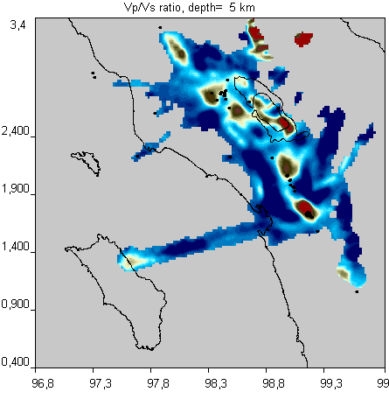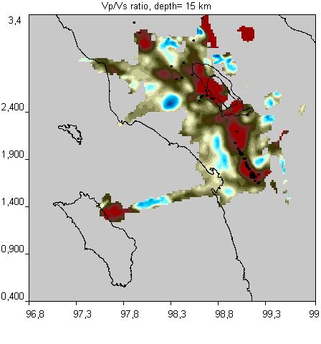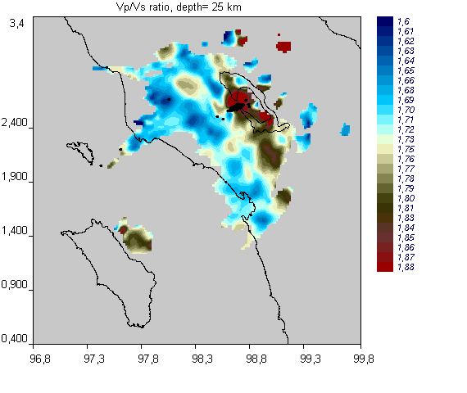
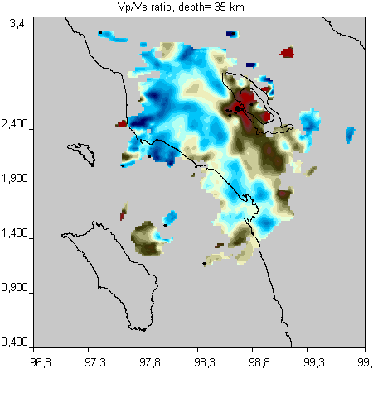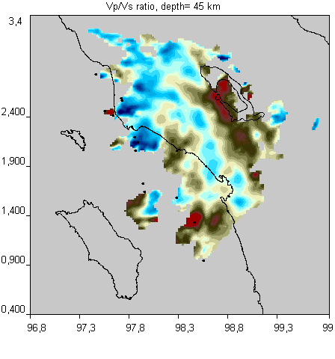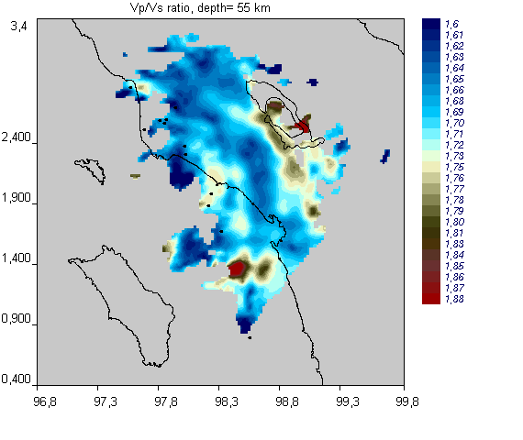
Figure 16. Inversion results for P velocity anomalies in 6 horizontal sections based on model “TOBA_REA/real_VPX”. Pictures are from:
“/PICS/TOBA_VPX/real_VPX/hor/abs_vpvs_5 M.png”, (M=1…6)

Table 3.1. Parameters of inversion for model “BOLIVAR_/MODEL_01”
Data processing | REAL DATA
Inversion scheme | Vp-Vp/Vs
Number of iterations | 5
1D optimization | YES
Parameterization | nodes
Figure with results | 16-17
Approximate calculation time: | 2 hours
Size of the model folder after calculations : | 28 Mb

Figure 17. Reconstructed values of Vp/Vs ratio in two vertical sections based on model: “TOBA_REA/real_VPX”. Picture is from: “/PICS/TOBA_REA/real_VPX/vert/abs_VpVs_5 M.PNG” (M=1,2) | 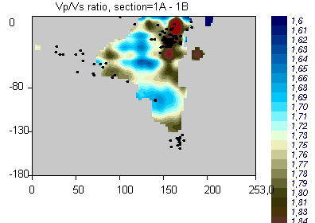
 | 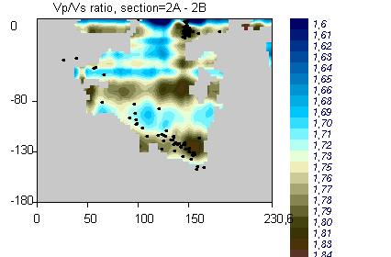

5. Tests for the GAP criterion, AREAS: “GAP__180”, “GAP__280”, “GAP__360”

These three tests were produced to check the efficiency of the GAP criterion which is used in most of LET studies. These examples are constructed based on a real network of stations deployed in Central Java in the framework of the MERAMEX Project (Koulakov et al., 2007, 2009). In these tests the data were supplemented with some out-of-network events which were taken from the ISC catalogue. Maximal epicentral distance to the center of the study area was 5 degrees. We considered three datasets with different selection criteria:
- Only events with GAP<180 are taken into consideration.
- Events with GAP<280 are taken into consideration.
- All events in the circle of 5 degrees around the network are used

These models are submitted to BSSA in the paper “Out-of-network events can be of great use for Local Earthquake Tomography”.

5.1. MODEL: “GAP__180/model_01”

Here we present the results of inversion with the use of only events with GAP<180.

General information about the data:
(obtained by project “/VISUAL/INFO_DATA”
Initial dataset:
Number of stations | 169
Number of events | 130
Number of P rays: | 4879
Number of S rays: | 2668
Dataset used for inversion:
Number of stations | 169
Number of events | 130
Number of P rays: | 4875
Number of S rays: | 2668

Table 5.1. Parameters of inversion for model “GAP__180/model_01”
Data processing | “real”
Inversion scheme | Vp-Vs
Number of iterations | 5
1D optimization | YES
Parameterization | nodes
Figure with results | 17-18
Approximate calculation time: | 1 hour
Size of the model folder after calculations : | 68 Mb

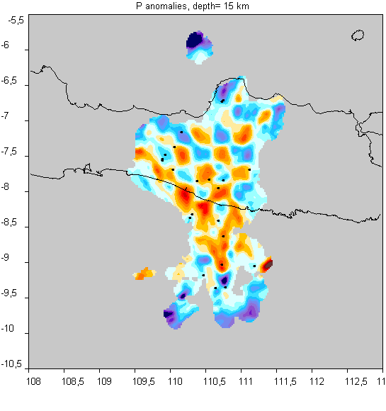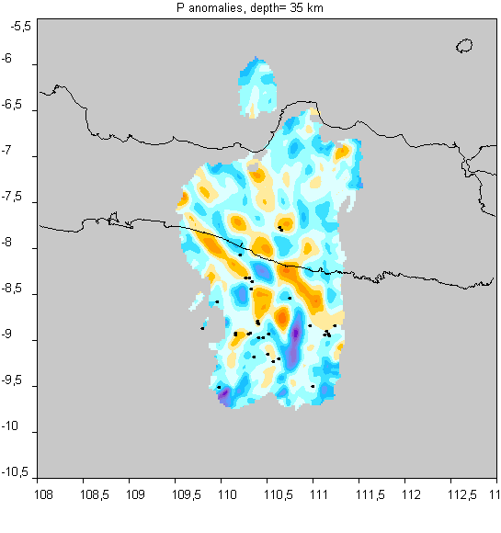
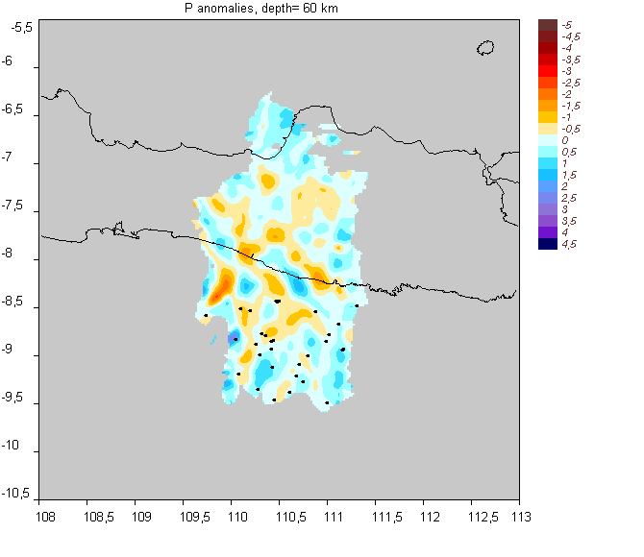
Figure 17. Inversion results for P velocity anomalies in 3 horizontal sections based on model “GAP__180/model_01”. Pictures are from:
“/PICS/GAP__180/model_01/hor/dv15_ M.png”, (M=1…6)

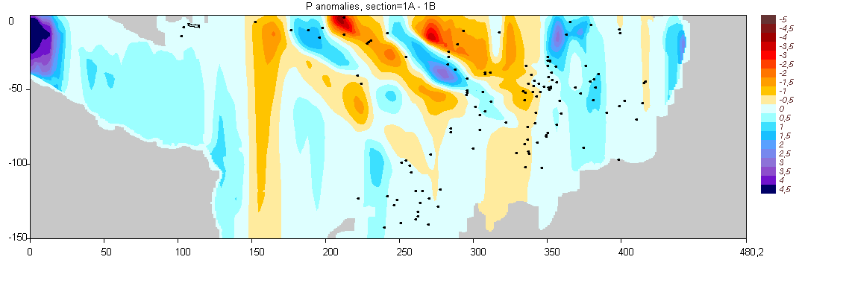
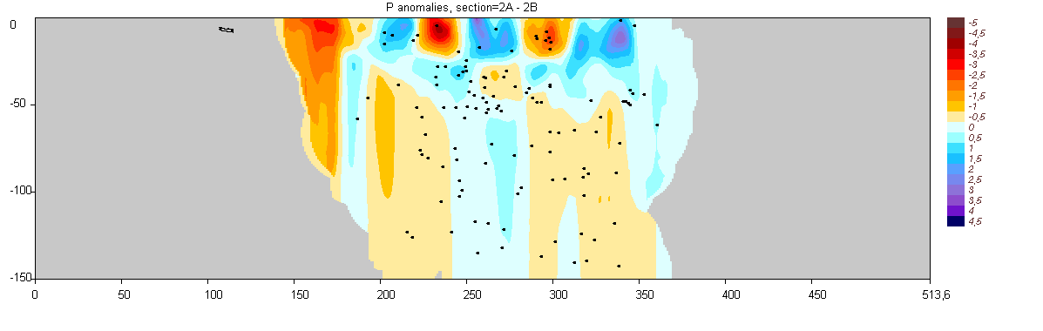
Figure 18. Reconstructed P anomalies in two vertical sections based on model: “GAP__180/model_01”. Picture is from: “/PICS/GAP__180/model_01/vert/ver_15 M.png” (M=1,2)

5.2. MODEL: “GAP__280/model_01”

Here we present the results of inversion with the use of only events with GAP<280.

General information about the data:
(obtained by project “/VISUAL/INFO_DATA”
Initial dataset:
Number of stations | 169
Number of events | 343
Number of P rays: | 13060
Number of S rays: | 6649
Dataset used for inversion:
Number of stations | 169
Number of events | 343
Number of P rays: | 13055
Number of S rays: | 6649

Table 5.2. Parameters of inversion for model “GAP__280/model_01”
Data processing | “real”
Inversion scheme | Vp-Vs
Number of iterations | 5
1D optimization | YES
Parameterization | nodes
Figure with results | 19-20
Approximate calculation time: | 3 hours 30 min
Size of the model folder after calculations : | 94 Mb

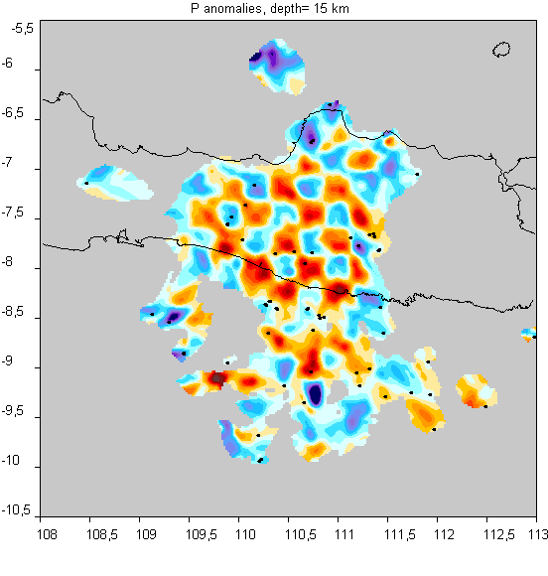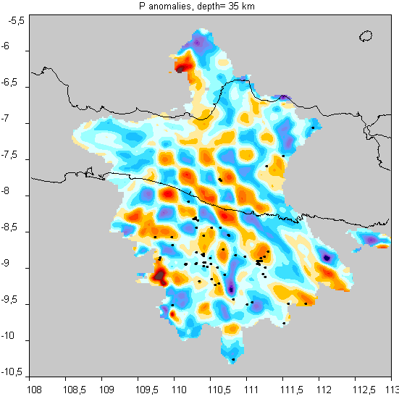
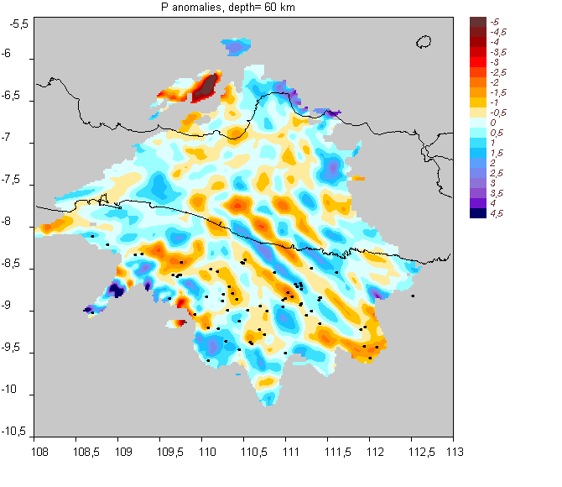
Figure 19. Inversion results for P velocity anomalies in 3 horizontal sections based on model “GAP__280/model_01”. Pictures are from:
“/PICS/GAP__180/model_01/hor/dv15_ M.png”, (M=1,3)
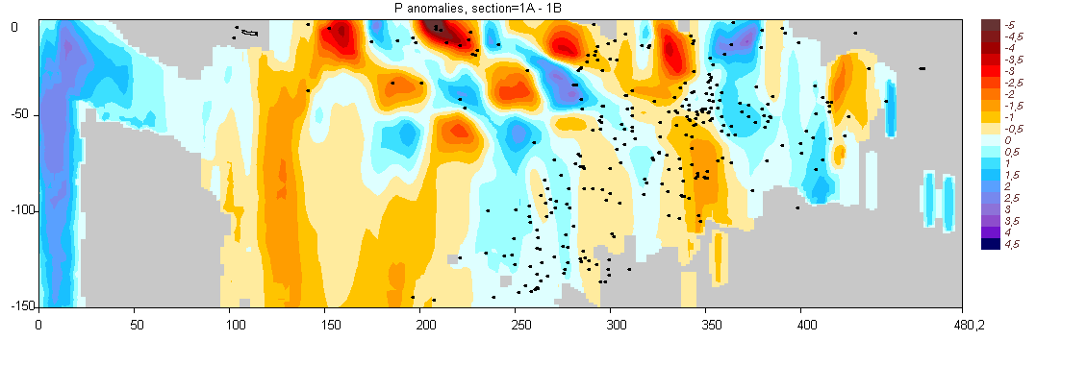
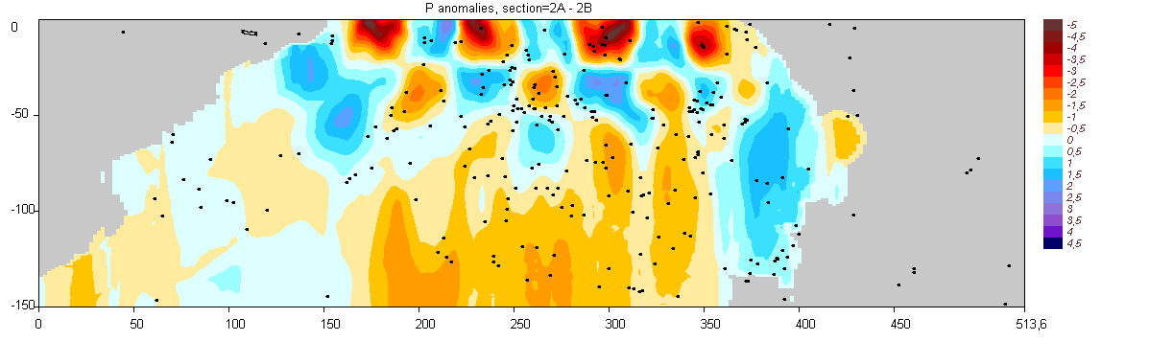
Figure 20. Reconstructed P anomalies in two vertical sections based on model: “GAP__280/model_01”. Picture is from: “/PICS/GAP__280/model_01/vert/ver_15 M.png” (M=1,2)
5.3. MODEL: “GAP__360/model_01”

General information about the data:
(obtained by project “/VISUAL/INFO_DATA”
Initial dataset:
Number of stations | 169
Number of events | 838
Number of P rays: | 31954
Number of S rays: | 15797
Dataset used for inversion:
Number of stations | 169
Number of events | 828
Number of P rays: | 31642
Number of S rays: | 15606

Table 5.3. Parameters of inversion for model “GAP__360/model_01”
Data processing | “real”
Inversion scheme | Vp-Vs
Number of iterations | 5
1D optimization | YES
Parameterization | nodes
Figure with results | 21-22
Approximate calculation time: | 11 hours
Size of the model folder after calculations : | 161 Mb

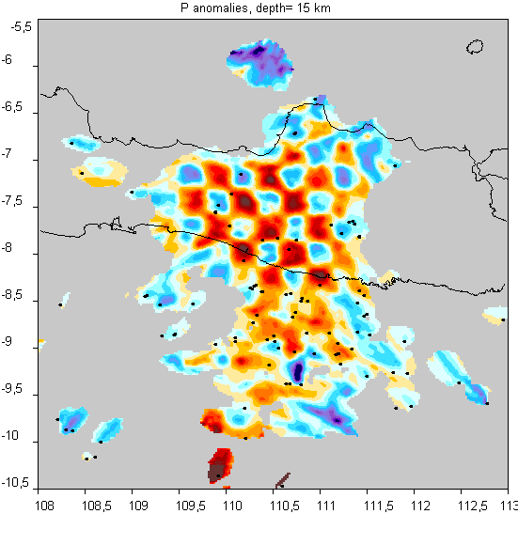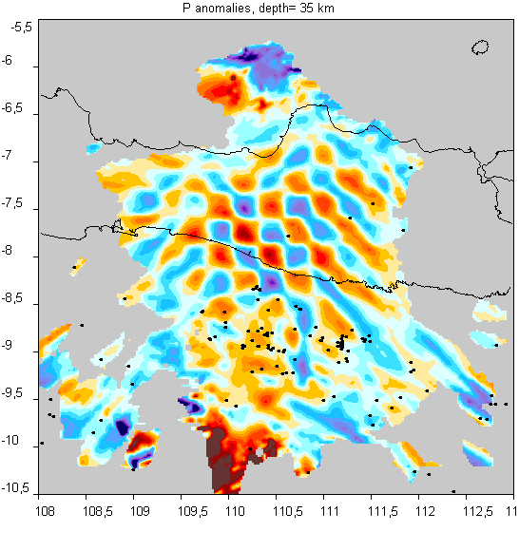
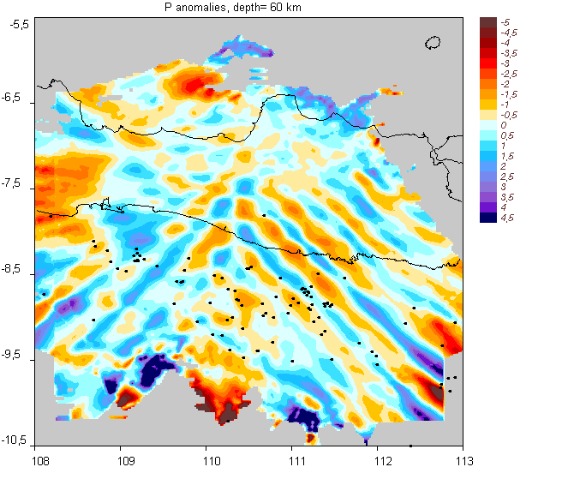
Figure 21. Inversion results for P and S velocity anomalies in horizontal section based on model “GAP__360. Pictures are from: “/PICS/GAP__360/model_01/hor/dv15_ M.png”, (M=1,3).

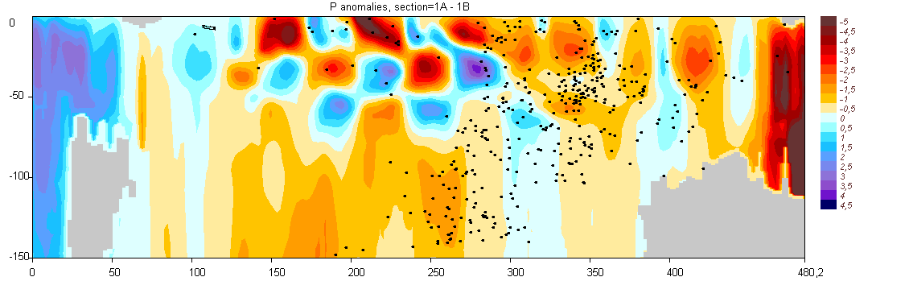
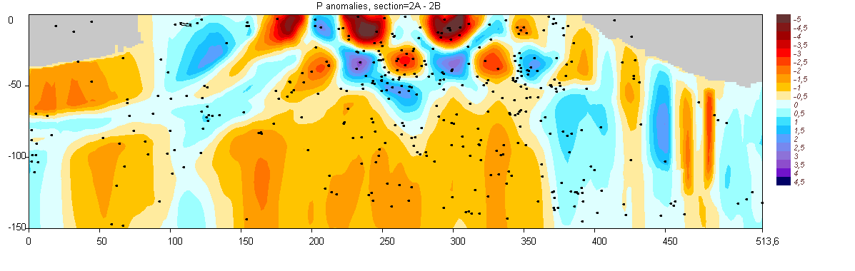
Figure 22. Reconstructed P anomalies in two vertical sections based on model: “GAP__360/model_01”. Picture is from: “/PICS/GAP__360/model_01/vert/ver_15 M.png” (M=1,2)
7.1. MODEL: “TURKEY__/model_01”

General information about the data:
Initial dataset:
Number of stations | 57
Number of events | 2454
Number of P rays: | 23265
Number of S rays: | 13182
Dataset used for inversion:
Number of stations | 40
Number of events | 2452
Number of P rays: | 23237
Number of S rays: | 13175

Table 9.1. Parameters of inversion for model “TURKEY__/model_01”
Data processing | “real”
Inversion scheme | Vp-Vs
Number of iterations | 5
1D optimization | YES
Parameterization | nodes
Figure with results | 24
Approximate calculation time: | 50 min
Size of the model folder after calculations : | 15 Mb

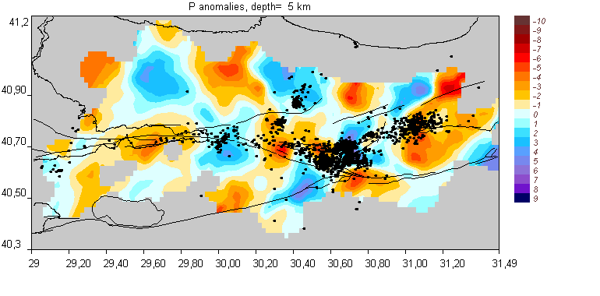
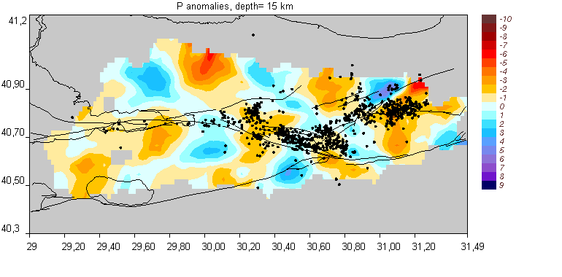
Figure 24. Inversion results for P velocity anomalies in 2 horizontal sections based on model “TURKEY__. Pictures are from: “/PICS/TURKEY__/model_01/hor/dv15_ M.png”, (M=1,2).
8.1. MODEL: “EGYPT_02/BOARD_01”

General information about the data:
(obtained by project “/VISUAL/INFO_DATA”
Initial dataset:
Number of stations | 228
Number of events | 3170
Number of P rays: | 26930
Number of S rays: | 5518
Dataset used for inversion:
Number of stations | 69
Number of events | 1124
Number of P rays: | 14199
Number of S rays: | 2920

Table 10.1. Parameters of inversion for model “EGYPT_02/BOARD_01”
Data processing | “real”
Inversion scheme | Vp-Vs
Number of iterations | 5
1D optimization | YES
Parameterization | nodes
Figure with results | 25

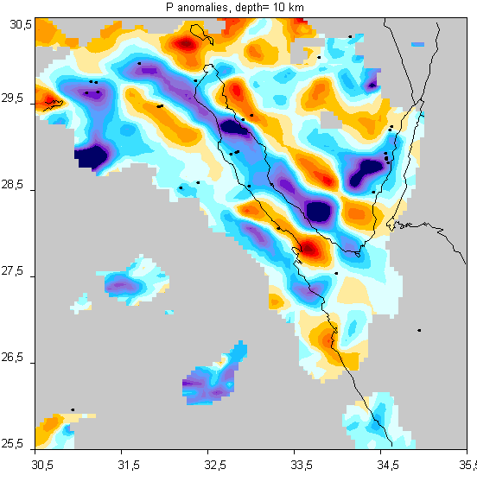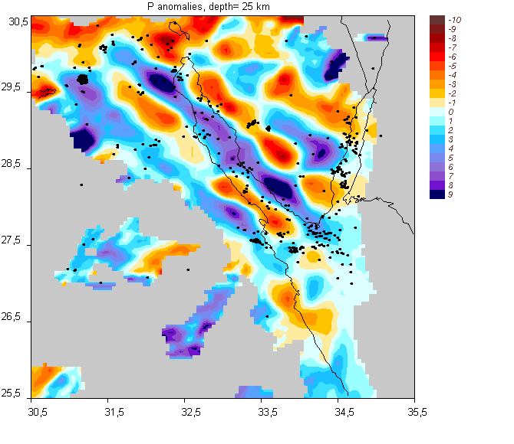
Figure 25. Inversion results for P velocity anomalies in 2 horizontal sections based on model “EGYPT_02. Pictures are from: “/PICS/EGYPT_02/BOARD_01/hor/dv15_ M.png”, (M=1,2).

